PROJECT DEMONSTRATION:

Running the API
- Install Postman or Thunder Client:
Use either tool to send API requests and check the server responses.
- Start the Backend Server:
Open the VS Code terminal in your project folder and run:
npm run dev
If the server starts successfully, the API will be ready to receive requests.

API Testing – User Registration
The registration API allows a new user to create an account.
- Route: POST /api/auth/register
- Access: Public
- Purpose: Creates a new user account and stores the user details securely in MongoDB.
Request Body:
{
"name": "dhana",
"email": "dhana@gmail.com",
"password": "123456"
}
Explanation:
- name: The user's name.
- email: The user's unique email address.
- password: The user's login password, which should be securely hashed before database storage.
After sending the request through Postman or Thunder Client, the server validates the details, creates the user account, and returns an appropriate response.

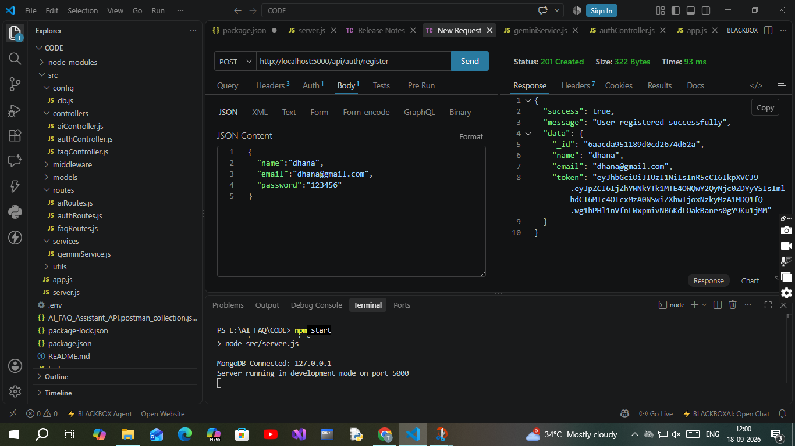

2. Profile Login Verification Query
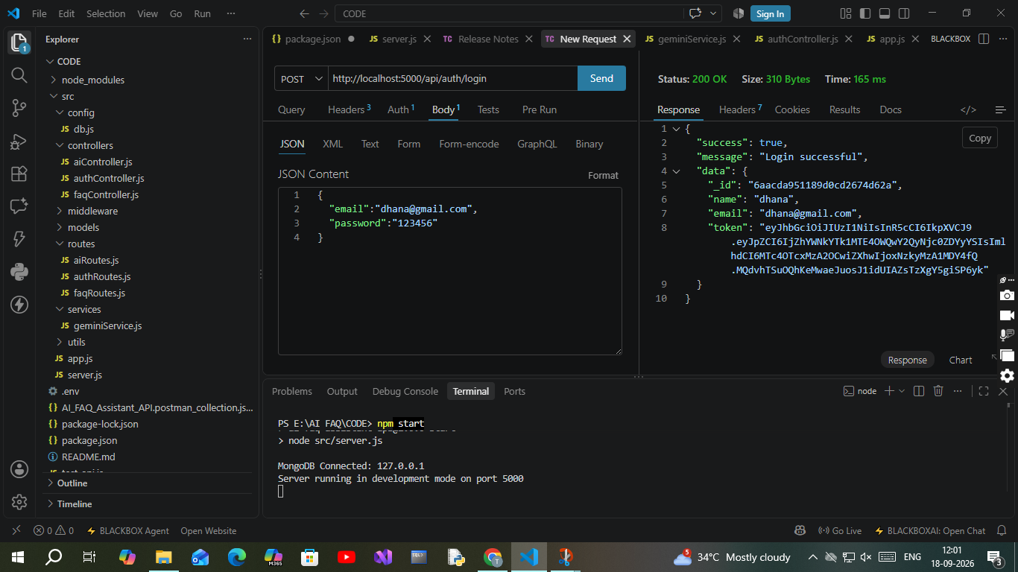
- Route: POST /api/auth/login
- Access: Public
- Payload Request Body JSON:
JSON

{
"email": "dhana@gmail.com",
"password": "123456"

}

Demo video: https://drive.google.com/file/d/1xspKJdfX0dzbOuFuBfmKJwz_XAbv1im9/view?usp=drivesdk

